**Pato Surveillance System (aka PATOSS)**

Introduction

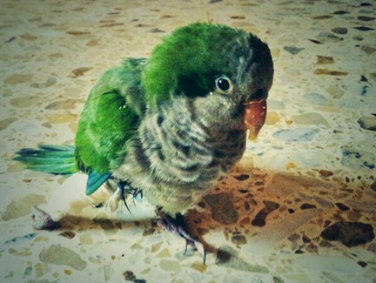The idea of setting up a system in order to monitor how a bird was doing when I’m not at come came out because, on the start of july, my friend Cristina and me, we did find a bird with a broken leg on the street.

We took him to the vet and Pato (the bird’s name) has his leg in plaster for one week. Once we took the plaster out, everything was ok except for two reasons:

* The leg was not perfectly healed so we had to keep him at home.
* I do not spend much time at home, so I needed to find a way in order to monitor how Pato was doing remotely.

I had a Raspberry Pi B Rev.2 lying at home, and since I work as a System Engineer for Linux / Unix systems, I though it wouldn’t be so difficult to set-up a system by using a Raspberry Pi board in order to monitor Pato via Internet.

What to monitor and how to do it?

The system had to be able to send a current picture from Pato’s cage, check the environment temperature and control the water level, so I had to set-up a webcam for the pictures, a thermometer for the temperature and a liquid level sensor for the water level.

*Taking pictures*

To set-up the webcam was quite straightforward. I did just plug it in, turn the Raspberry Pi on and run “lsusb”. By running lsusb you can check what USB devices does the system recognize and, in that case, the webcam was properly detected:

pi@raspberrypi ~ $ lsusb | grep C270

Bus 001 Device 006: ID 046d:0825 Logitech, Inc. Webcam C270

pi@raspberrypi ~ $

Since the webcam was properly detected, I just had to follow some simple steps to install and configure motion:

sudo apt-get install -y motion

Then, before starting it, I had to modify three parameters inside /etc/motion/motion.conf and give them the following values.

Daemon = OFF to ON

webcam_localhost = ON to OFF

start_motion_daemon= "no" to “yes”

And check how the Raspberry Pi was streaming video

<http://192.168.x.x:8081>

*Monitoring the temperature*

In order to check the environment temperature I bought a USB Temper thermometer via eBay.

However, in this case, there was a bit more work to be done in order to be able to check the temperature.

First, I had to ensure all the necessary dependencies are installed:

sudo apt-get install -y build-essential libusb-1.0.0 libusb-dev

We get the latest version from the temper binary via git

git clone https://github.com/bitplane/temper.git

Compile it!

cd temper/

make

And then, run the new binary :)

sudo ./temper 16-Jul-2013 00:02,26.089081

In case you want to get rid of the date and the time, you can use a script as I do:

TEMP=`sudo /home/pi/temper/temper | awk '{ print $2 }' | cut -d, -f2 | cut -c1-5` echo "$TEMP'C"

And then, run it:

pi@raspberrypi ~ $ ./temperatura.sh 25.63'C

*Reading the liquid level sensor*

I bought recently a PiFace board and I wanted to play a bit with it, so I thought this would be a good opportunity to use it for the first time.

It couldn’t be easier.

The liquid level sensor was connected to digital input zero. In order to check if there's water or not, I just have to run the following script. If there's enough water, it would return 1.

import piface.pfio as pfio

pfio.init()

print pfio.digital_read(0)

And then, run it!

pi@raspberrypi ~ $ python boya.py 1

Sending tweets from the Raspberry Pi

Once everything was set-up from software and hardware point of view, now was time to find out how to send tweets.

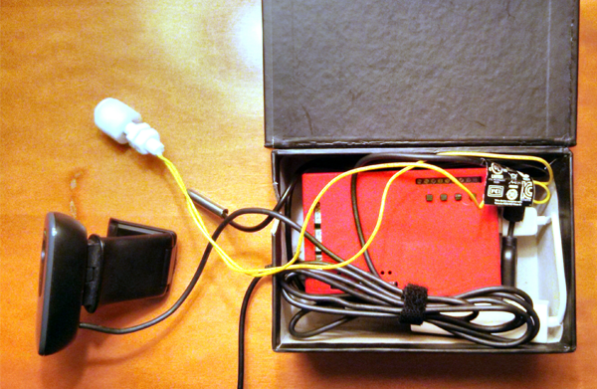

I did open a Twitpic account in order to make things easier, so a just had to send an e-mail with an attached picture and the information I wanted to be posted. In order to do that, I wrote a really simple script:

#!/bin/sh

CPUTMP=`/home/pi/cpu_temp.sh`

ENVTMP=`/home/pi/temperatura.sh`

LIQUID=`python /home/pi/boya.py`

if [ ${LIQUID} -eq 1 ]; then

AGUA='Water level OK'

elif [ ${LIQUID} -eq 0 ]; then

AGUA='Pato needs water'

fi

SUBJECT="RPi temp: ${CPUTMP}. Room temp: ${ENVTMP}. ${AGUA}. " echo "" | mutt -a /tmp/motion/patoss.jpg -s "`echo ${SUBJECT}`" -- [xxxx@twitpic.com](mailto:xxxx@twitpic.com)

And this is what is being posted on Twitter:

